Protap Chandro Roy


Address: GP Cha/ Mohakhali, Dhaka
Home Phone: 01723-181800
Office Phone :09613666888
Mobile : 01719122506

e-mail : royprotap92@gmail.com
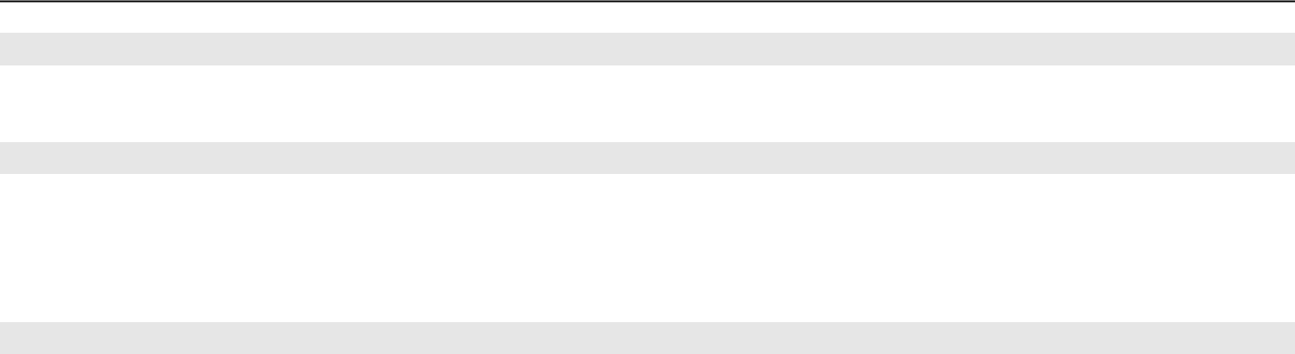

Career Objective:

To build a progressive career with an accomplished company who has the reputation of good working environment and also has the commitment of developing future.

Career Summary:

Assistant Restaurant Manager, Transcom Foods Limited, QSR Restaurant, KFC Bangladesh.

Manage a Yum-owned restaurant within the policies and guidelines of the company to ensure customer satisfaction and profit maximization.
Ensure national and local health and safety codes, and company safety and security polices are met.
Control Profit & Loss (i.e. plan attainment) by following cash control/security procedures, maintaining inventory management.

Special Qualification:

Languages: Well versed in both written and spoken over Bengali and English.
Software: Microsoft word, excel (any version), Power point, Emailing


Employment History:

Total Year of Experience : 7 Year(s)

- Assistant Restaurant Manager .( Jul 1, 2019 - Continuing) Transcom Food Limited.
Location : KFC Gulshan , Bangladesh

Department: Management

- Shift Manager ( 1st Aug , 2016 – 30th Jun-2019) Transcom Foods Limited.
Location : KFC Gulshan. Dhaka,Bangladesh.
Department : Management.

3.Team Member. ( June 5, 2012 - July 30,2015)
Transcom Foods Limited
Location : KFC Uttara, Dhaka, Bangladesh.
Department : CASH, Service ,Kitchen, Supply Base ,Home Delivery

Academic Qualification:
 |  | Exam Title |  | Concentration/Major |  | Institute | Result | Pas.Year | Duration
 |  | MSC |  | Statistics |  | National University | CGPA: 2.49 out of 4 | 2017 | 1 years
 |  | BSC (Honours) |  | Statistics |  | National University | CGPA: 2.83 out of 4 | 2015 | 4 years
 |  | HSC |  | Business Studies |  | Cant. Punblic School & College, | CGPA: 4.30 out of 5 | 2010 | 2 Years
 |  | HSC |  |  |  | Rangpur | CGPA: 4.30 out of 5 | 2010 | 2 Years
 |  | SSC |  | Business Studies |  | Nilphamari Govt. High School | CGPA:4.69 | 2008 | -
 |  | SSC |  |  |  | Nilphamari Govt. High School | out of 5 | 2008 | -

Training Summary:


Training Title | Topic | Institute | Country | Location | Year | Duration
 | Labour Management,
Leading A Restaurant | Manage P&L, Direct
Leading A Restaurant | customer service, Safety | YUM International | Bangladesh | Dhaka | 2019 | 1 Month
(LAR-1)
(LAR-1) | and security, Putting All
 | together
 | Bench planning, BSC,
Leading A Restaurant | Coaching Team, Driving | KFC Bangladesh, | Bangladesh | Dhaka | 2019 | 1 Month
(LAR-2) | Sales, Recruiting, | YUM International
 | Forecasting ,

 |  |  |  |  | Product Management, |  |  |  |  |  | 5, Bir Uttam Mir
 | Leading A Shift, |  |  |  | Customer Satisfaction, |  | KFC Bangladesh, |  |  | Bangladesh | Shawket Ali Shorok, |  | 2014 |  | 1 Month
 | (LAS) |  |  |  | Cash Management & |  | YUM International |  |  | Bangladesh | Gulshan Avenue, |  | 2014 |  | 1 Month
 |  |  |  |  | Team Training etc. |  |  |  |  |  | Dhaka.
 | Computer |  |  |  | MS Word, MS Excel, |  | Beacon |  |  | Bangladesh | Dhaka |  | 2008 |  | 3 Month
 |  |  |  |  |  | Internet |  |  |  |  |  |  |  |  | 3 Month
Language Proficiency:
 | Language |  |  |  |  | Reading |  |  |  | Writing |  |  | Speaking
 | Bangoli |  |  |  |  | High |  |  |  | High |  |  | High
 | English |  |  |  |  | High |  |  |  | High |  |  | Medium
 | Hindi |  |  |  |  | Low |  |  |  | Low |  |  | Low
Personal Details :
Father's Name |  |  |  |  | : Anil Chandro Roy
Mother's Name |  |  |  |  | : Parul Roy
Date of Birth |  |  |  |  | : April,11. 1992
Gender |  |  |  |  | : Male
Marital Status |  |  |  |  | : Unmarried
Nationality |  |  |  |  | : Bangladeshi
National Id No. |  |  |  |  | : 6906694028
Religion |  |  |  |  | : Hindu
Permanent Address |  |  |  |  | : Vill: Harishchandro path, PO: Bahalipara, PS: Jaldhaka, Diss: Nilphamari.
Current Location |  |  |  |  | : Dhaka
Reference (s):
 | Name | : Iqbal Hosen
 | Organization : Transcom Foods Limited, KFC Bangladesh
 | Designation | : Area Coach
 | Phone | : 01714-045758

Signature:
Protap Roy

